# IT 230 Coding Activity Submission Template

Submit your work on the coding activities for Modules One, Two, Three, Four, and Six in this document. In addition to this document, you should submit a ZIP file containing all your Visual Studio project files and source code that can be run in Visual Studio on a different computer.

For each coding activity, complete the following steps:

* Download and rename this document to meet the file naming conventions requested in the assignment instructions.
* Fill in the required information below by replacing the bracketed text with the relevant information.
* Submit this document and your ZIP file for grading and feedback. Your ZIP file should follow the same naming conventions.

Document your work in the coding activity by completing each of the following items:

1. Provide a screenshot of the output that resulted from running your program successfully in Visual Studio. See the coding assignment instructions for an example of what should be included in the screenshot. Your screenshot must include the following elements:
   1. Your last name as the first printed text on the screen
   2. Verification that the program is fully functioning and data results are accurate for the given problem

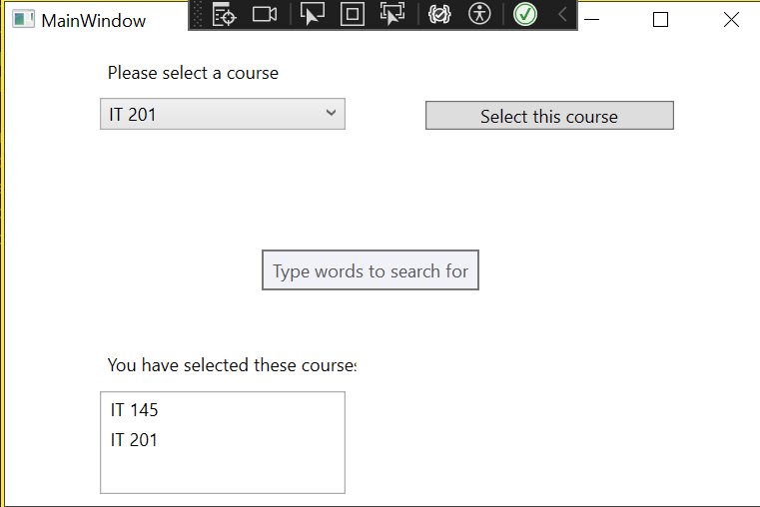

1. Copy and paste the source code text you wrote for this assignment from the *.cs file into the space below. Only providing the *.cs files or a screenshot does not meet the requirements for this part of the assignment. Code should be logically organized. It should also follow proper syntax and conventions noted in the Coding Activity Guidelines and Rubric.

using System;  
using System.Collections.Generic;  
using System.Linq;  
using System.Text;  
using System.Threading.Tasks;  
using System.Windows;  
using System.Windows.Controls;  
using System.Windows.Data;  
using System.Windows.Documents;  
using System.Windows.Input;  
using System.Windows.Media;  
using System.Windows.Media.Imaging;  
using System.Windows.Navigation;  
using System.Windows.Shapes;  
  
namespace CreateClassesObjs  
{  
 /// <summary>  
 /// Interaction logic for MainWindow.xaml  
 /// </summary>  
 public partial class MainWindow : Window  
 {  
  
 Course choice;  
  
 public MainWindow()  
 {  
 InitializeComponent();  
 }  
  
 private void Window_Loaded(object sender, RoutedEventArgs e)  
 {  
 Course course1 = new Course();  
 Course course2 = new Course();  
 Course course3 = new Course();  
 Course course4 = new Course();  
 Course course5 = new Course();  
 Course course6 = new Course();  
 Course course7 = new Course();  
  
 course1.SetName("IT 145");  
 course2.SetName("IT 200");  
 course3.SetName("IT 201");  
 course4.SetName("IT 270");  
 course5.SetName("IT 315");  
 course6.SetName("IT 328");  
 course7.SetName("IT 330");  
  
  
  
 this.comboBox.Items.Add(course1);  
 this.comboBox.Items.Add(course2);  
 this.comboBox.Items.Add(course3);  
 this.comboBox.Items.Add(course4);  
 this.comboBox.Items.Add(course5);  
 this.comboBox.Items.Add(course6);  
 this.comboBox.Items.Add(course7);  
 }  
  
 private void button_Click(object sender, RoutedEventArgs e)  
 {  
 if (this.comboBox.SelectedItem != null)  
 {  
 choice = (Course)(this.comboBox.SelectedItem);  
 this.listBox.Items.Add(choice.GetName());  
 }  
 }  
  
 }  
}

1. Show that you understand the task by explaining the design of your program in the space below. Include the process and steps you took to write your code. Explain how you arrived at the solution to the problem and completed the activity.  
     
   To start off, the big missing thing of this assignment was the missing Course class. In a separate file, the Course class must be created off the main project to provide the necessary information to complete the project. The second error was the setName method being written wrong and should be rewritten to SetName. The last error was that in list.Box the object reference was being added instead of the course name.
2. Reflect on your learning experience and what you learned from completing the activity.

This project required adding new classes to the project, which proved to be interesting to learn how to mess around with, along with partial classes.